# 

**Cro**í **Laighean Credit Union (CLCU)**

**CONFIGURATION SOLUTION DOCUMENT**

**Accounts**

**Version 1.3**

Document History

|  |  |  |  |  |
| --- | --- | --- | --- | --- |
| Version | Date | Author / Changed By | Change Description | Sign Off |
| 1.0 | 13- April-2021 | Maha Kamal & Nivedhitha Senthil | Initial Draft |  |
| 1.1 | 21-April-2021 | Maha Kamal | Added new requirement about Signatories, Section 4.4.6 |  |
| 1.2 | 30-April-2021 | Maha Kamal | Updated CSD according to comments given by Client. Section updated are 4.1.1,4.2.1, 4.2.2, 4.3.2, 4.3.4, 4.4.1, 4.4.2, 4.4.5 |  |
| 1.3 | 20-May-2021 | Maha Kamal | Updated section 4.3.1 |  |

Table of Contents

1. Introduction 4

1.1 Document Purpose 4

1.2 Document References 4

2. Summary Explanation 4

3. Coverage 4

3.1 General 4

3.2 Assumptions 5

3.3 Glossary 5

4. Configuration 5

4.1 Menu items 5

4.1.1 Account Shortcuts 5

4.2 Screens / Versions 7

4.2.1 New Accounts 7

4.2.2 Reports Tab 7

4.3 Parameters 8

4.3.1 Products 8

4.3.2 Account Conditions 9

4.3.3 Overdraft Restrictions 9

4.3.4 IBAN 9

4.4 Other Requirements 9

4.4.1 Posting Restrictions 9

4.4.2 Fee Collection 9

4.4.3 Prize Draw 10

4.4.4 Current Accounts 10

4.4.5 Special Share Accounts 10

4.4.6 Signatories 10

# Introduction

## Document Purpose

The core purpose of the document is to provide consolidated details about layout and field name changes, shortcuts to functionality, task management and changes to enquires captured in the Accounts BASD to cover the credit union’s requirements for the accounts in R19.

Parameters for all account products are also provided in this document.

## Document References

References below are to all relevant functional documents, these documents contain the requirements being addressed by this CSD.

|  |  |  |  |
| --- | --- | --- | --- |
| Document Name | Description | Author, Company | Document |
| RTM V1.0 | Requirement Traceability Matrix | Maha Kamal & Nivedhitha Senthil |  |
|  |  |  |  |

# Summary Explanation

During configuration workshops and requirement-gathering sessions with CLCU, the identified requirements were discussed and analysed in order to suggest the best solution and/or approach for each requirement. As much as existing functionalities have been used, alternatives were discussed to offer the Client an appropriate solution for 100% of potential scenarios.

As per the project mandate, utilisation of the existing core functionality was encouraged to address these requirements. Where local development is required, this is outlined below.

Moreover, changes to screen layout with additional fields being required, and shortcuts to commonly-used functionality were identified based on inputs from credit unions’ respective SMEs to ensure a full coverage of the business requirements.

# Coverage

## General

This document describes configuration settings, parameterisation, and screen layouts required to meet the Client’s documented requirements.

Any development / coding requirements will be described separately in Functional and Technical Specification Documents (FSDs and TSDs).

## Assumptions

Assuming all accounts can be held jointly and are held in EUR.

## Glossary

|  |  |
| --- | --- |
| **Term** | **Description** |
| *BRD* | *Business Requirement Document* |
| *CSD* | *Configuration Solution Document* |
| *FSD* | *Functional Specification Document* |
| *IDD* | *Interface Design Document* |
| *IRD* | *Interface Requirement Document* |
| *ISB* | *Initial System Build* |
| *RTM* | *Requirement Traceability Matrix* |

# Configuration

## Menu items

### Account Shortcuts

The Shortcuts section under “Accounts” should be amended as follows:

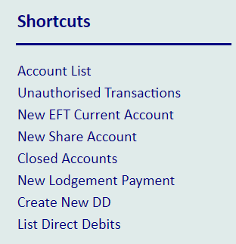

The below shortcuts to be removed:

New EFT current account

The below shortcuts to be added:

1. New Family Account
2. New Current Account
3. New Savings Stamps Account
4. New Non-Personal Shares Account
5. New Non-Personal Deposit Account

Therefore, the Shortcuts menu will appear as follows:

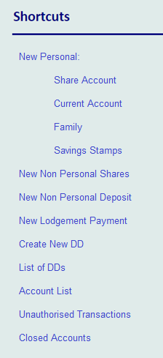

**AC Accounts:**

The below shortcuts to be removed:

On AC ACCOUNT, delete the new account shortcut.

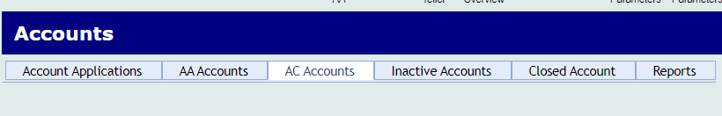

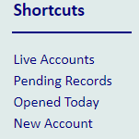

Therefore, the Shortcuts menu will appear as follows:

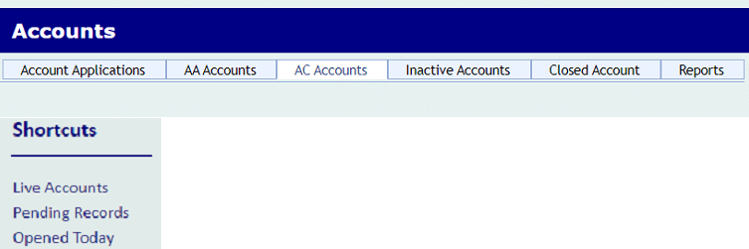

Accounts will only be created through member’s SMV.

## Screens / Versions

### New Accounts

Account creation screens should be self-authorised therefore Number of Authorisers should =0

### Reports Tab

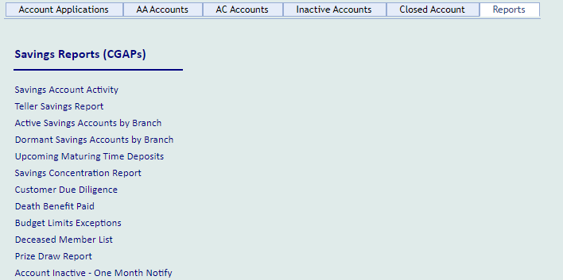

The below shortcuts to be removed:

1. Budget Limits Exceptions
2. Deceased Member List
3. Savings account Activity
4. Upcoming Maturing Time Deposits

The below are the details to be amended

**Death benefit paid:**

Add Date of Birth and Date Joined to “Death Benefit Paid” report and rename it to Deceased member report.

Therefore, section to appear as follows:

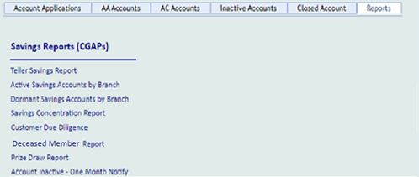

## Parameters

The purpose of this section is to define the account parameters required by CLCU with reference to IBS product builder functionality:

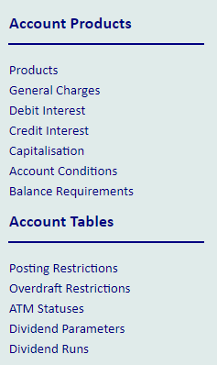

### Products

The below accounts products are required:

|  |  |
| --- | --- |
| **Product Name** | **Category** |
| Shares | 7313 |
| Family | 7314 |
| Savings Stamps | 6002 |
| Deposit Account | 6015 |
| Current Account | 1001 |
| Non Personal Shares | 7310 |
| Non Personal Deposit | 7311 |

The configuration details are attached in the file



For Deposit Account change the "GB Description" to "Dep Accounts" and keep the category as "Deposit Account", that way it will remain the same in the statements and online everywhere.

Similarly, for Non Personal Deposit change to the "GB Description" to "NonP Dep Accounts" and the category will remain as "Non Personal Deposit Account".

### Account Conditions

The below group conditions are required to be set for all account products:

Generate IBAN = Y

Inactive Months = 36 (for all accounts).

For new Share Accounts, Minimum Balance = 5.00 (leave blank for other account types)

Non-Personal Share: Max balance is EUR 5. Minimum Balance is EUR 5. Mandatory for Non-Individuals.

### Overdraft Restrictions

Overdrafts are not currently allowed, but might be used in future. CLCU to confirm more on this point.

### IBAN

Any new accounts in T24 would be set up with the IBAN containing EDCN991042 as the institution identifier and sort code. As part of the migration we can bring over the account numbers (last 8 digits of the IBAN) from Progress.

Existing IBANs in legacy that relate to credit unions that have merged with CLCU, for example: IE46CDDC99218310002157, would change to IEXXEDCN99104210002157.

## Other Requirements

### Posting Restrictions

Account closure posting restriction should be defaulted to 95 for Share Accounts on the Account closure screen, although it can be amended by the user

Deposit Accounts will be created with a posting restriction "no new lodgements" (during migration). Deposit account non mandatory for Individuals and no new accounts of this type will be created within T24.

### Fee Collection

Fees is applicable on current account but it will be covered in a separate MPCAS doc.

### Prize Draw

Prize draw is EUR 35 per year. Prize Draw STO to be hardcoded to 31 OCT.

### Current Accounts

For Current Accounts, Max balance of EUR 10,000 working independently of shares accounts.

### Special Share Accounts

CLCU does NOT need different Special Shares accounts. Remove Special Shares account.

### Signatories

Currently CLCU have a Delegated Authority and manually reviews signatory mandates. Document generation is required when a signatory is created/amended at ACCOUNT level.

The current form used by CLCU will be shared and based on this, the Signatories Tab at ACCOUNT level will be updated.